**A survey of an Inventory management system**

**INTRODUCTION:**

The problem of inventory control is one of the most important in organizational management. As a rule, there is no standard solution – the conditions at each company or firm are unique and include many different features and limitations. An occurring task of the mathematical model’s development and determining the optimal inventory control strategy is related to this problem. Features of inventory management models are that the resulting optimal solutions can be implemented in a fast-changing situation where, for example, the conditions are changed daily. There is a need for new and effective methods for modeling systems associated with inventory management, in the face of uncertainty. Uncertainty exists regarding the control object, as the process of obtaining the necessary information about the object is not always possible. The solution to such complex tasks requires the use of systems analysis and the development of a systematic approach to the problem of management in general. Inventory models are distinguished by the assumptions made about the key variables: demand, cost structure, and physical characteristics of the system. These assumptions may not suit to the real environment. There is a great deal of uncertainty and variability.

**Inventory management:**

Stocks (reserves) are created to carry out the normal activities of the company. Proper and timely determination of the optimal inventory control strategy allows for freeing a significant amount of assets, frozen in the form of stocks, which ultimately increases the efficiency of resource use. Even though there are literally millions of different types of products manufactured in our society, there are only two fundamental decisions that one has to make when controlling inventory: 1. How large should an inventory replenishment order be? 2. When should an inventory replenishment order be placed? The objectives of inventory management often reduce the problem if it is more profitable to do quickly but more expensive or slower but cheaper. Such a strategy will be optimal inventory control, which minimizes the sum of milestones costs associated with the production, storage, and inventory shortage per unit of time or for a specific (including infinite) amount of time

**Types of demand classification:**

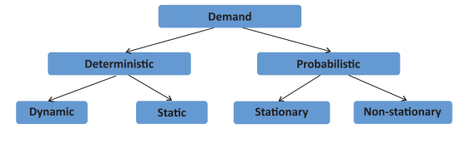

Stationary distribution with known parameters. This type of demand follows a probability distribution that is known or estimated from historical data. Commonly used distributions include normal, gamma, and Poisson. Non-stationary probabilistic demand. This type of demand behaves like a random walk that evolves over time, with regular changes in its direction and rate of growth or decline. On the basis of the demand sources, demands are divided into independent and dependent. Independent demand is the demand that consists of the individual consumer’s demands, each of them feeling the need independently of the other. Dependent demand occurs when a manufacturer uses a number of components for the manufacture of finished goods, and the demand for each component is associated with others and depends on the production plan of manufacturing.

**METHODS:**

**Knowledge-based approach:**

This type of recommender system attempts to suggest objects based on inferences about users’ needs and preferences. This approach assists users in the determination of suitable solutions from complex product and service assortments. These solutions are based on exploiting deep knowledge about the product domain to figure out the best wishes of the customer. In Knowledge-based recommendation techniques, the relationship between customer requirements and products can be explicitly modelled in an underlying knowledge base. They can use rules and patterns to recommend items based on functional knowledge of how a specific item meets a particular user need. Knowledge-based recommendations perform reasoning about what products meet the user’s requirements by employing techniques such as a quantitative decision support tool.

**JRS using Web scraping:**

This technique came into existence right around the year when the internet was introduced to the world. The data that are available on the internet will be in forms of tables, comments, articles, and job listings which are embedded in different HTML tags.

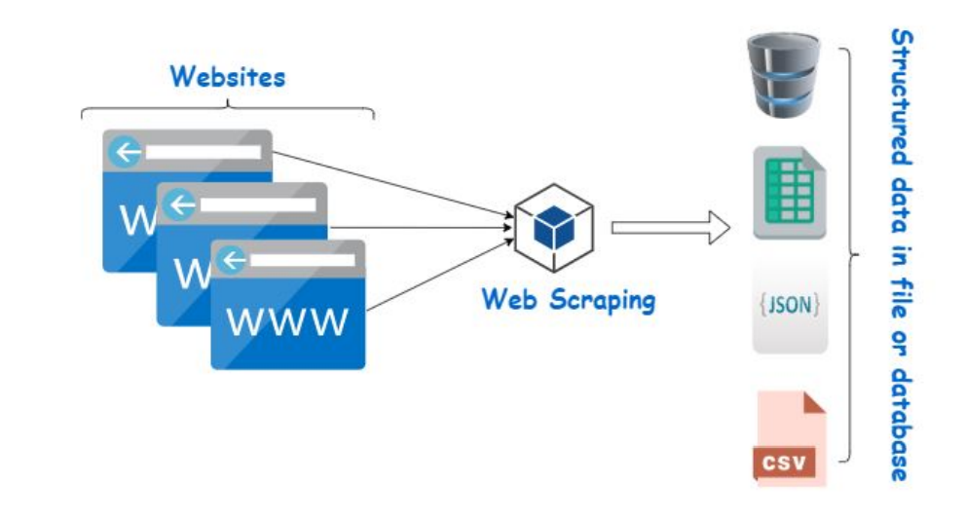

Web scraping is also termed as screen scraping, web data extraction, or even web harvesting. Every website has it's own structure, so the method of web scrapping is hard to generalize for every website. We rely on automating or creating a web crawler using python or R programming language.

**Content-based JRS:**

Content-based recommender systems (CBRs) in the context of JRS are models which, to construct a recommendation, only use a semantic similarity measure between the user profile and the set of available vacancies. I.e., the semantic similarity is used as a proxy for estimating the relevance of each vacancy to the job seeker. In CBRs, one creates vector representations of the vacancy and user profile in an unsupervised way, i.e., the dimensions of these representations may not have an intuitive interpretation.

**Collaborative Filtering (CF):**

CF is a popular recommendation algorithm that bases its predictions and recommendations on the ratings or behavior of other users in the system. There are two basic types: User-based CF and Item-based CF.

• User-based CF

• Item-based CF

**System requirements for candidates/job recommendation:**

* An easy-to-use interface that doesn’t require advanced training, support or documentation.
* Automation for eliminating manual processes of business functions related to inventory management.
* A reliable, secure database that provides accurate, real-time data.
* Performance that enables fast, actionable inventory monitoring and control.
* The ability for administrators to easily add software modules with minimal configuration so that the system is scalable.
* Software integrations and automated features that minimize manual inventory updates or inputs.

**The Conclusion:**

In this article, we used a literature analysis of many journals and proceedings related to Inventory management has to do with keeping accurate records of goods that are ready for shipment. This often means having enough stock of goods to the inventory totals as well as subtracting the most recent shipments of finished goods to buyers. When the company has a return policy in place, there is usually a sub-category contained in the finished goods inventory to

account for any returned goods that are reclassified or second-grade quality.

Accurately maintaining figures on the finished goods inventory makes it possible to quickly convey information to sales personnel as to what is available and ready for shipment at any given time by the buyer.

Inventory management is important for keeping costs down while meeting regulations. Supply and demand is a delicate balance, and inventory management hopes to ensure that the balance is undisturbed. Highly trained

Inventory management and high-quality software will help make Inventory management a success. The ROI of Inventory management will be seen in the forms of increased revenue and profits, a positive employee atmosphere, and on

An overall increase in customer satisfaction.

**Existing platform:**

1. NetSuite
2. Zoho inventory
3. Ecomdash
4. Cin7
5. FishBowl

**References:**

www.capital line .com

www.economictimes.com

www.blonnet.com

www.moneycontrol.com

www.reportgallery.com

www.annualreportservice.com